Title: | LIN Network One Slave implementation  SW Component < 1.0 >

History
Issue status  (Index) | Maturity/Date  (draft/invalid/valid)  (dd-mmm-yyyy) | Author  Department | Check/Release  Department | Description
2 | Draft  25-Nov-15 | Óscar Miranda | Guillermo Ramirez | Creation of the SW design document (template) with purpose.
7 | Draft  28-Nov-15 | Óscar Miranda | Guillermo Ramirez | Purpose (section 1) extended. One section added called Definitions and abbreviations with some abbreviations added. Section 3 updated. Table 1 added. And multilayer architecture description and diagram added.
8 | Draft  29-Nov-15 | Óscar Miranda | Guillermo Ramirez | Title changed. Class diagram added.
9 | Draft  29-Nov-15 | Óscar Miranda | Guillermo Ramirez | LIN Network block diagram added. Some functions in section 5 added.
10 | Draft  30-Nov-15 | Óscar Miranda | Guillermo Ramirez | Master signals added to Table 1. Multilayer architecture and class diagrams and Targets modified.
12 | Draft  01-Dec-15 | Óscar Miranda | Guillermo Ramirez | Global_init(),LIN_StateMachine(), UartTxMsg(),scheduler diagram and Led_StMach() diagrams added.Class and multilayer diagram modified. And requirements added in functional decomposition.
24 | 7-Dec-15 | Óscar Miranda | Óscar Miranda | Application and Basic software modified. Architecture modified. Requirements added to functions. Class diagram added,
25 | 8-Dec-15 | Óscar Miranda | Óscar Miranda | Class diagram description added. Scheduler diagram modified and a description was added. Some new requirements added to LIN_init().
27 | 8-Dec-15 | Guillermo Ramirez | Oscar Miranda | Format and grammar issues corrected. Purpose corrected according to review.
31 | 9-Dec-15 | Guillermo Ramirez | Oscar Miranda | Sequence Diagram modified according to new design
32 | 9-Dec-15 | Guillermo Ramirez | Oscar Miranda | History updated
35 | 13-Dec-15 | Óscar Miranda | Óscar Miranda | New application added to section 5.3, and to class and multilayer diagrams. And descriptions of sections 4.1 and 4.3 modificated.
36 | 14-Dec-15 | Guillermo Ramirez | Oscar Miranda | Reorganized

Table of Contents
1 Purpose 5
2 Definitions and abbreviations 5
3 Realization constraints and targets 6
3.1 Targets 6
3.2 Constraints 7
4 SW Conceptual design 9
4.1 Architecture Layer Diagram 9
4.2 Class Diagram 11
4.3 Sequence Diagram 12
5 SW Component internal breakdown 13
5.1 Functional Decomposition 13
5.2 OS 13
5.2.1 Scheduler 13
5.2.1.1 Void kernel (void) 13
5.2.1.2 Void Tick_Flag (void) 13
5.3 Application 14
5.3.1 LED_App 14
5.3.1.1 Void Led_StateMachine (void) 14
5.3.1.2 T_UBYTE GetLedState(void) 15
5.3.1.3 Void ChangeLedState (T_UBYTE lul_LedState) 15
5.3.2 SlaveApp 15
5.3.2.1 Void Slave_StateMachine (void) 15
5.3.2.2 T_UBYTE GetNodeState (void) 16
5.3.2.3 Void ChangeNodeState (T_UBYTE lul_LedState) 16
5.3.3 Void ProcessCommand (T_UBYTE laub_Msg[]) 16
5.4.1.1 Void SendLedCommand (T_UBYTE lub_LedFlg) 17
5.4.1.2 Void SendNodeCommand (T_UBYTE lub_NodeFlg) 17
5.4 Basic Software 18
5.4.1 Slave4_Rsp_Rx_Tx 18
5.4.1.4 void LINFlex_0_RX_ISR() 18
5.4.1.5 void LINFlex_0_TX_ISR() 18
5.5.1 Global_Init 19
5.5.1.1 void Global_Init(void) 19
5.4.2 STM 19
5.5.2.1 void STM_init(void) 19
5.4.3 System 20
5.5.3.1 void initModesAndClock(void) 20
5.4.4 GPIO 20
5.5.4.1 void GPIO_Init() 20
5.5.4.2 void GPIO_En(void) 20
5.5.4.3 T_UBYTE GPIO_GetState(T_UWORD ch) 20
5.5.4.4 void GPIO_SetState(T_UWORD ch, T_UBYTE value) 21
5.4.5 SW_Interrs 21
5.5.5.1 void INTC__init(void) 21
5.4.6 LIN 21
5.5.6.1 void LIN__init(void) 21

Purpose
The purpose is to explain and describes the functionality of the LIN Slave program, so the user/programmer will have an overview of the program to facilitate its understanding. This document describes the modules, functions and its functionality of the LIN Slave program. Shows the diagrams of the structure and the classes inside it.

Definitions and abbreviations
Definitions
Node | An electronic control unit (ECU) connected to a LIN bus

Abbreviations

GPIO  LIN  STM  SIUL | General purpose inputs and outputs  Local Interconnect Network  System Timer Module  System Integration Unit Lite
LINFlex | It’s the microcontroller interface for LIN communication protocol
MAL  GRVOMG | Microcontroller Abstraction Layer  Acronym of the name’s initials of the members of this project, Guillermo Ramírez Vázquez and Óscar Francisco Miranda García
Req. | Requirement. To see requirements consult reference 1
References
N° | Document name | Reference
1 | LIN_Traceability_Matrix.xls 7 | 1
2 | LIN_Network_Database.xlsm 1.0 | 2
3 | LIN-Spec_2-2A.pdf | 3
4 | MPC5606B Reference Manual.pdf 7.1 | 4

Realization constraints and targets

Targets

This project only involves the implementation of one slave, labeled in subsequent sections as Slave 4, of a LIN network. Here is an overview of the principal project’s features:
- It only concerns the implementation of Slave 4 in a 2.1/2.2 LIN network with a baud rate of 9600 bit/s. Req. 1.1, 1.3 and 1.4
- Master will command all slaves. Req. 2.1.2
- Master will command slave 4 to go enable/disable or turn the led off/on or toggle. Req. 2.2.2
- Slave 4 will send its state (enable/disable) to master node. Req. 3.1.1
- Slave 4 will send its led state to master node. Req. 3.1.3
- Slave 4 will send the acronym GRVOMG to master node. Req. 3.1.6
- Slave 4 will send number 4 (team’s number) to master node. Req. 3.1.7
- The last six sentences mentioned above are signals that will start in a specified byte and will have different length. See table 1.

Table 1. Signals of the slave as subscriber or publisher.
Signal Name | Signal Msg | Signal Start Byte | Signal Start Bit | Signal Length (bits) | Signal Type | Signal Endianness | Signal Description
Master_cmdForAll (subscriber) | MASTER_CMD_ALL, ID = 0xCF | 0 | 0 | 4 | T_cmdType | LE | Command for all nodes
Master_cmdForSlave4  (subscriber) | MASTER_CMD_SLV4,  ID = 0xD3 | 0 | 0 | 4 | T_cmdType | LE | Command for slave 4
slave4_LEDstat  (publisher) | SLAVE4_RSP, ID =0xA3 | 0 | 0 | 2 | t_LEDstat | LE | Return LED Status
slave4_enabled (publisher) | SLAVE4_RSP, ID =0xA3 | 1 | 0 | 1 | t_boolean | LE | Return Node Status
slave4_supplier (publisher) | SLAVE4_ID, ID =0x73 | 0 | 0 | 8 | scalar | LE | Return Team number
slave4_serial (publisher) | SLAVE4_ID, ID =0x73 | 1 | 0 | 48 | array | LE | Returns initials of members team

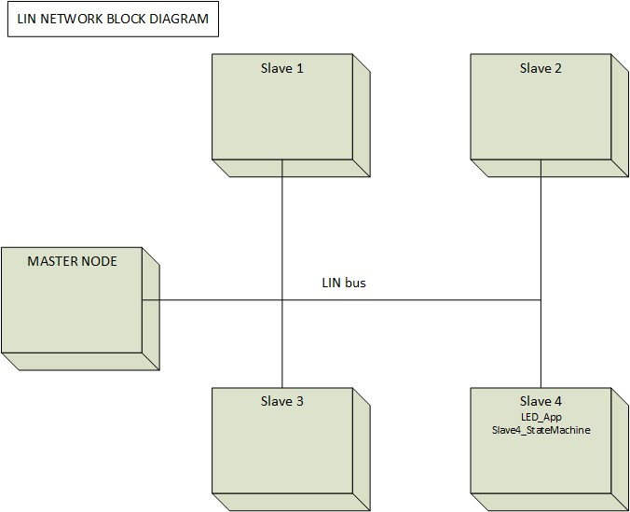

The network showed in the figure above represents the full integrated system of the LIN Network.
The assignment is develop the slave node labeled as Slave 4, with all its internal components and the required actions to perform.

Constraints
A possible constraint could be the PowerPC architecture of the hardware where the software will be implemented, which is a development board MPC5606B of Freescale. Here are some concerning specifications and a block diagram that could help when trying to export the project into another platform:
- MPC5606B MCU in a 144LQFP package.
- On-board JTAG connection via open source OSBDM circuit using the MPC9S08JM MCU
- Operating Frequency (Max): 64 MHz.
- Total DMA Channels 16.
- Internal Flash (KB): 512
- GPIOs: 149.
- EEPROM: 64 KB DataFlash®
- RAM: Up to 96 KB
- Timer: 16 bits up to 64 channels

The principal modules that are used in this project:
- SIUL: Configure GPIO and Pad Control (software control of external pins), used to declare the 1 output to turn off/on a LED
- STM: used for timing purposes, that is, to configure the pre-scaler clock factor and configure the speed of the LED.
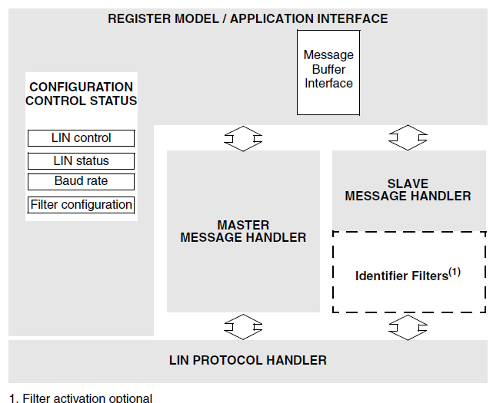
- LINFlex: used as an interface with the 2.1 LIN protocol and the following features: classic and enhanced checksum, 8 byte buffer for transmission/reception, advanced error detection, autonomous header and transmit/receive data handling for slave mode, and others. On the next page there is a block diagram of this module.
MPC5606B LINFlex block diagram

SW Conceptual design

Architecture Layer Diagram

The project is divided into four layers:
- OS: This module will control the Slave4_State_Machine with a scheduler, and defines the tasks (periods and offsets), and the clock tick of the scheduler.
- Application: This layer corresponds to the outputs of the system, that is, the toggling of the LED, the handle of the messages/signals, and the Slave 4 state machine:
- LED_App. This controls the turning on/off, and toggling of the LED.
- SlaveApp. This controls the state of the node: enabler, disabled.
- ProcessCommand. This state machine receives the signal of the master and differ whether it is a Led command or a Slave command.
- Basic Software: This layer corresponds to the interface that controls the UART and LIN communication (transmission/reception), and the configuration of the LED that will be used by LED_App:
- Slave4_Rsp_Rx_Tx. This module is the responsible to send messages/signals to master node, such messages are defined in Table 1.
- MAL: In this layer the configuration of the microcontroller is defined. That is, the system clock, the timers (STM), the LIN module and the GPIO are initialized. Global_Init is the module responsible to do so.

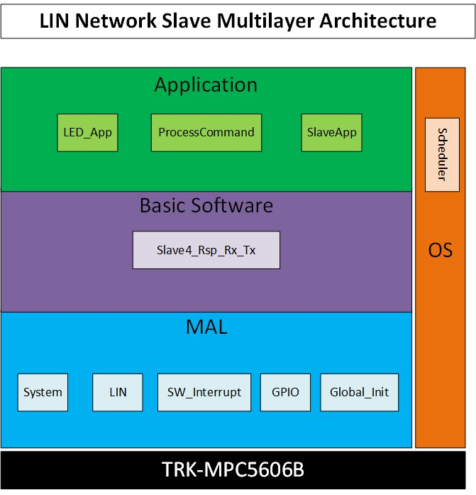

Class Diagram
This diagram shows the structure of the project and its modules, contain their respective attributes and methods. This diagram is similar to the multilayer diagram, with the difference that here are depicted the external classes. These files are hardware dependent, except the stdtypedef class that are the standard type definitions of Continental’s projects.

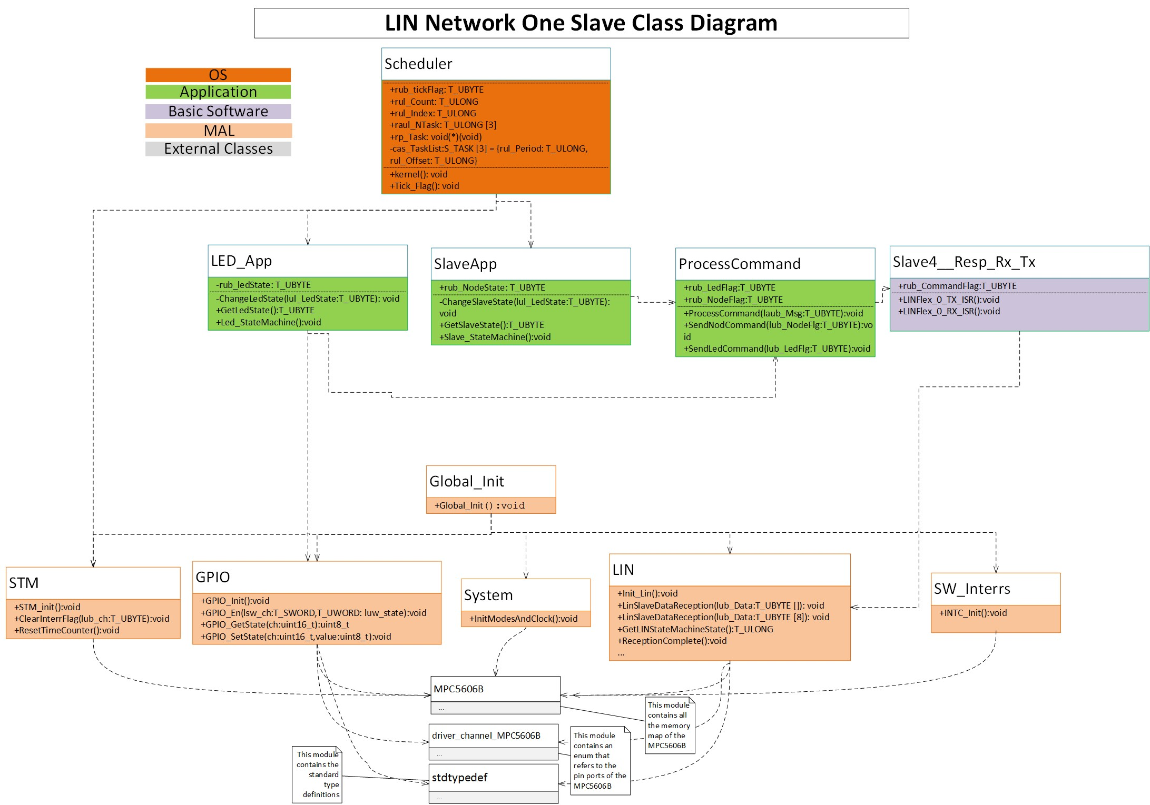

Sequence Diagram

The next diagram shows the interaction between an asynchronous LIN state machine slave and a command processing task whose job is read the command sent by the master and determine whether it is a led command or a node command. When a command is received, the corresponding task must change their state variable, and this new state variable could be read or received by the LIN state machine. The Led_StateMachine period task is 10 ms, this value was defined by considering the req. 1.5 that states that the toggling speed must be of 100 transition/ms, with a tolerance error of 10%. So the tolerance defines the period of this task.

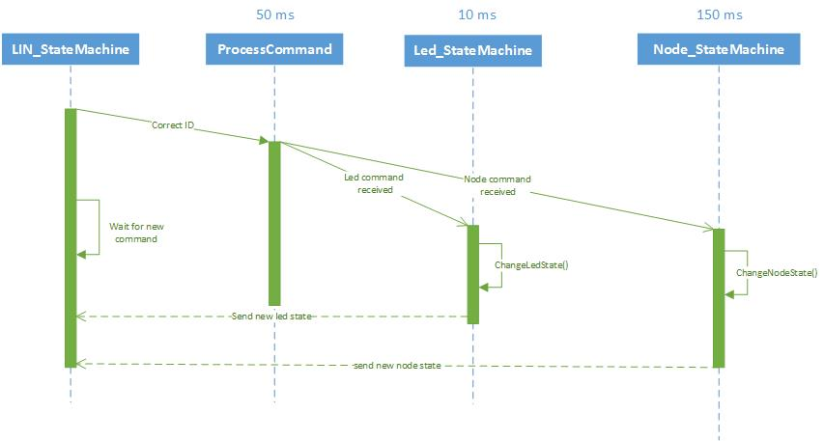

SW Component internal breakdown

Functional Decomposition

OS

Scheduler

5.2.1.1 Void kernel (void)

Description | The scheduler is contained inside a function called kernel. This function starts by doing an indexing of the task, assigning the offset. This process occurs only once in each execution of the code.  Then an infinite loop starts, the tick of the scheduler is defined by a flag called ub_TickFlag, which was configured to raise every millisecond. Once it was acquired it is restarted to zero.  Now, inside the if there is a for cycle which who through all the task accessing to their offset with and if, whenever the offset is over zero it will decrease, for every task. When one of the offset, of whichever task, reach zero, the else of the if will be active and will stablish the period of the task and will call it using the pointer previously defined.
Parameters | void
Return Value | void
Precondition | ------------
Post condition | ------------
Error Conditions | Not defined
Requirement | --------

5.2.1.2 Void Tick_Flag (void)
Description | Check if the channel 0 of the STM has reached 1ms and set a flag called ub_TickFlag when reached.
Parameters | void
Return Value | void
Precondition | The counter value of the STM is equal to the compare value of channel 0 and counter interrupt flag has been set.
Post condition | ------------------
Error Conditions | Not defined
Requirement | 1.5

Application

LED_App

5.3.1.1 Void Led_StateMachine (void)
Description | This state machine will be called every millisecond.  The initial state is OFF. The variable state can have three states: OFF, ON, and TOGGLING.  If the node is enabled then the master command is listened.  When the command is received the rub_LedFlag is changed depending on the command. The state variable will be changed in the subsequent tick. If the node is disable, the current state is kept, until a different command, when node is enabled, is listened.
Parameters | No parameters
Return Value | There is no return value
Precondition | ----
Post condition | ----
Error Conditions | Not defined
Requirement | 1.2

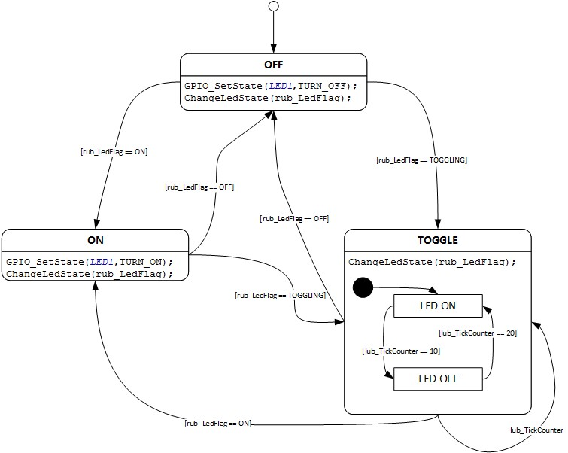

5.3.1.2 T_UBYTE GetLedState(void)
Description | Get the current state of the led
Parameters | No parameters
Return Value | T_UBYTE
Precondition | ----
Post condition | ----
Error Conditions | Not defined
Requirement | -----

5.3.1.3 Void ChangeLedState (T_UBYTE lul_LedState)
Description | Change the state variable depending on the command.
Parameters | T_UBYTE lul_LedState  Possible states: OFF, ON, and TOGGLING.
Return Value | There is no return value
Precondition | ----
Post condition | ----
Error Conditions | Not defined
Requirement | 1.2

SlaveApp

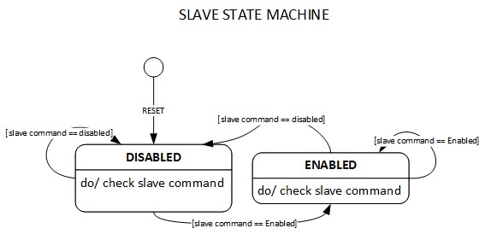
5.3.2.1 Void Slave_StateMachine (void)
Description | This state machine will be called every 500ms. The initial state is DISABLE. Node variable state can have two states: DISABLED and ENABLED. When master commands, the state variable is changed by using rub_NodeFlag variable that is the command.
Parameters | No parameters
Return Value | There is no return value
Precondition | ----
Post condition | ----
Error Conditions | Not defined
Requirement | 1.2

5.3.2.2 T_UBYTE GetNodeState (void)
Description | Get the current state of the node
Parameters | No parameters
Return Value | T_UBYTE current state of the node
Precondition | ----
Post condition | ----
Error Conditions | Not defined
Requirement | -----

5.3.2.3 Void ChangeNodeState (T_UBYTE lul_LedState)
Description | Change the state variable depending on the command.
Parameters | T_UBYTE lul_LedState  Possible states: OFF, ON, and TOGGLING.
Return Value | There is no return value
Precondition | ----
Post condition | ----
Error Conditions | Not defined
Requirement | 1.2

ProcessCommand

Void ProcessCommand (T_UBYTE laub_Msg)
Description | Reads the response of the master and determines which command the slave will execute: whether to do nothing, request the Led_StateMachine to turn on/off or toggle, or request the Node_StateMachine to disable or enable the node.
Parameters | T_UBYTE laub_Msg[1]  Possible values: CMD_LED_ON, CMD_LED_OFF or CMD_LED_TOGGLING, CMD_DISABLE_SLV, CMD_ENABLE_SLV.
Return Value | There is no return value
Precondition | ----
Post condition | ----
Error Conditions | Not defined
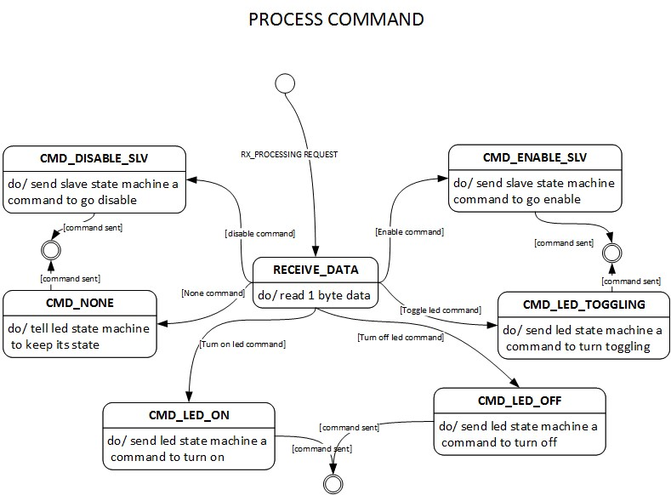  Requirement | 2.2.2,2.3.2

5.3.3.2 Void SendLedCommand (T_UBYTE lub_LedFlg)
Description | Change the value of the global variable led flag that will be used by the Led_StateMachine to change its state variable.
Parameters | T_UBYTE lub_LedFlg  Possible values: CMD_LED_ON, CMD_LED_OFF or CMD_LED_TOGGLING.
Return Value | There is no return value
Precondition | ----
Post condition | ----
Error Conditions | Not defined
Requirement | 1.2

5.3.3.3 Void SendNodeCommand (T_UBYTE lub_NodeFlg)
Description | Change the value of the global variable node flag that will be used by the Node_StateMachine to change its state variable.
Parameters | T_UBYTE lub_NodeFlg  Possible values: CMD_DISABLE_SLV, CMD_ENABLE_SLV.
Return Value | There is no return value
Precondition | ----
Post condition | ----
Error Conditions | Not defined
Requirement | 1.2,

Basic Software

Slave4_Rsp_Rx_Tx

5.4.1.4 void LINFlex_0_RX_ISR()
Description | This function is called when a reception id from the filters defined match. When this happens the master command is listened and send the command either to node state machine or led state machine.
Parameters | No parameters
Return Value | There is no return value
Precondition | ----
Post condition | ----
Error Conditions | Not defined
Requirement | 1.3, 2.1.2, 2.2.2

5.4.1.5 void LINFlex_0_TX_ISR()
Description | This function is called when a data transmission or a header interrupt take place depending on the filters defined. If a eader interrupt happens, the data transmission request is made. When data is transmitted, an acknowledge of it is made.
Parameters | No parameters
Return Value | There is no return value
Precondition | ----
Post condition | ----
Error Conditions | Not defined
Requirement | 1.3, 3.2 to 3.6
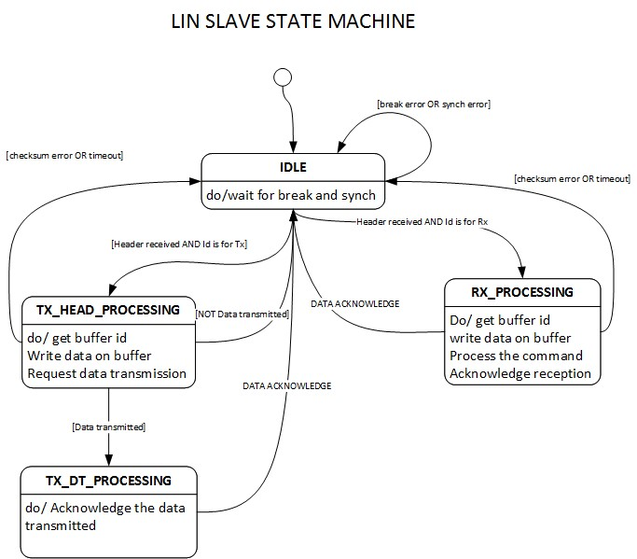
MAL

MAL

5.5.1 Global_Init

5.5.1.1 void Global_Init(void)
Description | Initializes the modes and clock of the system, the STM module, the GPIO ports, and the software interrupts of INTC
Parameters | No parameters
Return Value | There is no return value
Precondition | Main(has started)
Post condition | ----
Error Conditions | Not defined
Requirement | -----
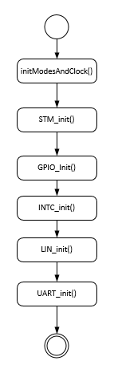

STM

5.5.2.1 void STM_init(void)
Description | Enables the STM module and configures the prescaler, the channel 0, and the compare registers
Parameters | No parameters
Return Value | There is no return value
Precondition | Global_Init(called)
Post condition | ----
Error Conditions | Not defined
Requirement | ------

System

5.5.3.1 void initModesAndClock(void)
Description | Enables the run mode and the signal clock speed to 64 MHz
Parameters | No parameters
Return Value | There is no return value
Precondition | Global_Init(called)
Post condition | ----
Error Conditions | Not defined
Requirement | ------

GPIO

5.5.4.1 void GPIO_Init()
Description | Enables the pins –using GPIO_En() function- that will be used for the led bar, the led up and down indicators as outputs and the up(close), down(open), and anti-pinch buttons as inputs.
Parameters | No parameters
Return Value | There is no return value
Precondition | Global_Init(called)
Post condition | ----
Error Conditions | Not defined
Requirement | -----

5.5.4.2 void GPIO_En(void)
Description | Enables a pin of the GPIO that will be used
Parameters | No parameters
Return Value | There is no return value
Precondition | Global_Init(called)
Post condition | ----
Error Conditions | Not defined
Requirement | ------

5.5.4.3 T_UBYTE GPIO_GetState(T_UWORD ch)
Description | Get the state of a pin, the pin is defined in ch, that is, it reads if the pin is on or off.
Parameters | T_UWORD ch  Number of the GPIO register/channel
Return Value | T_UBYTE result  Pin reading (on/off) of specified channel
Precondition | Global_Init(called)
Post condition | ----
Error Conditions | Not defined
Requirement | -----

5.5.4.4 void GPIO_SetState(T_UWORD ch, T_UBYTE value)
Description | Set the value received to the pin specified in ch, using value to turn it on/off.
Parameters | T_UWORD ch  Number of the GPIO register/channel  T_UBYTE value  Turn off/on the specified channel
Return Value | void
Precondition | Global_Init(called)
Post condition | ----
Error Conditions | Not defined
Requirement | ----

SW_Interrs

5.5.5.1 void INTC__init(void)
Description | Enables the interrupt module of MPC5606B
Parameters | No parameters
Return Value | There is no return value
Precondition | Global_Init(called)
Post condition | ----
Error Conditions | Not defined
Requirement | ------

LIN

5.5.6.1 void LIN__init(void)
Description | Enables and configures the LINFlex module of MPC5606B to work with four filters: MASTER_CMD_ALL, MASTER_CMD_SLV4, SLAVE4_RSP and SLAVE4_ID. Here the baud rate is defined, the break, length, the Rx/Tx interruptions, etc.
Parameters | No parameters
Return Value | There is no return value
Precondition | Global_Init(called)
Post condition | ----
Error Conditions | Not defined
Requirement | 1.3.1,1.4, 2.1.2, 2.2.2, 2.3.2,2.4.2

